Db:Rds

Registration(mysql),Login(mysql),wishlist(mongodb)

For Registration:vineesha-nasa-registrationservice used same rds for registration , login and wishlist

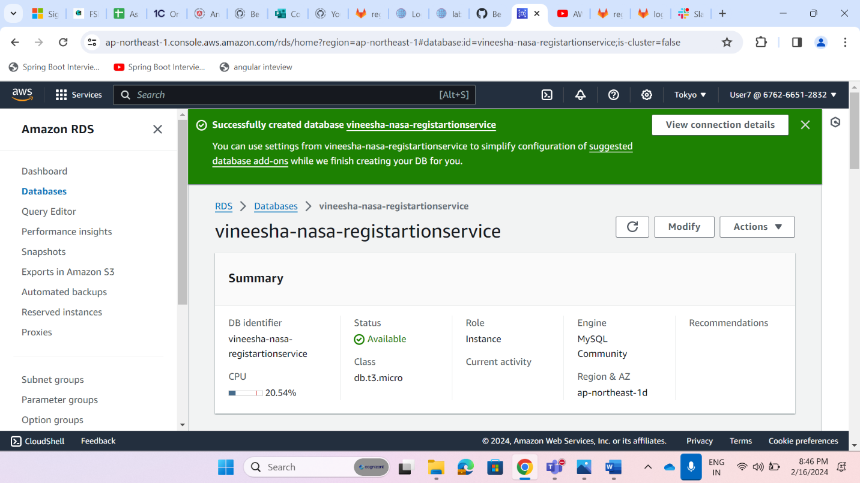

Added securitygroup :edit inbound rules

Custom Tcp 3306 Anywhere

For registration I used configserver to get database details,so after db creation in rds need to change endpoint,username and password username(root,pwd:rootroot) so change details in gitlab config server

local

spring.datasource.url=jdbc:mysql://localhost:3306/registerdb

spring.datasource.driver-class-name=com.mysql.cj.jdbc.Driver

spring.datasource.username=root

spring.datasource.password=Root@123

spring.jpa.hibernate.ddl-auto=update

spring.jpa.show-sql=true

after cloud

spring.datasource.url=jdbc:mysql://vineesha-nasaregistration.chu0eeioae10.ap-northeast-1.rds.amazonaws.com:3306/registerdb

spring.datasource.driver-class-name=com.mysql.cj.jdbc.Driver

spring.datasource.username=root

spring.datasource.password=rootroot

spring.jpa.hibernate.ddl-auto=update

spring.jpa.show-sql=true

tested with cloud

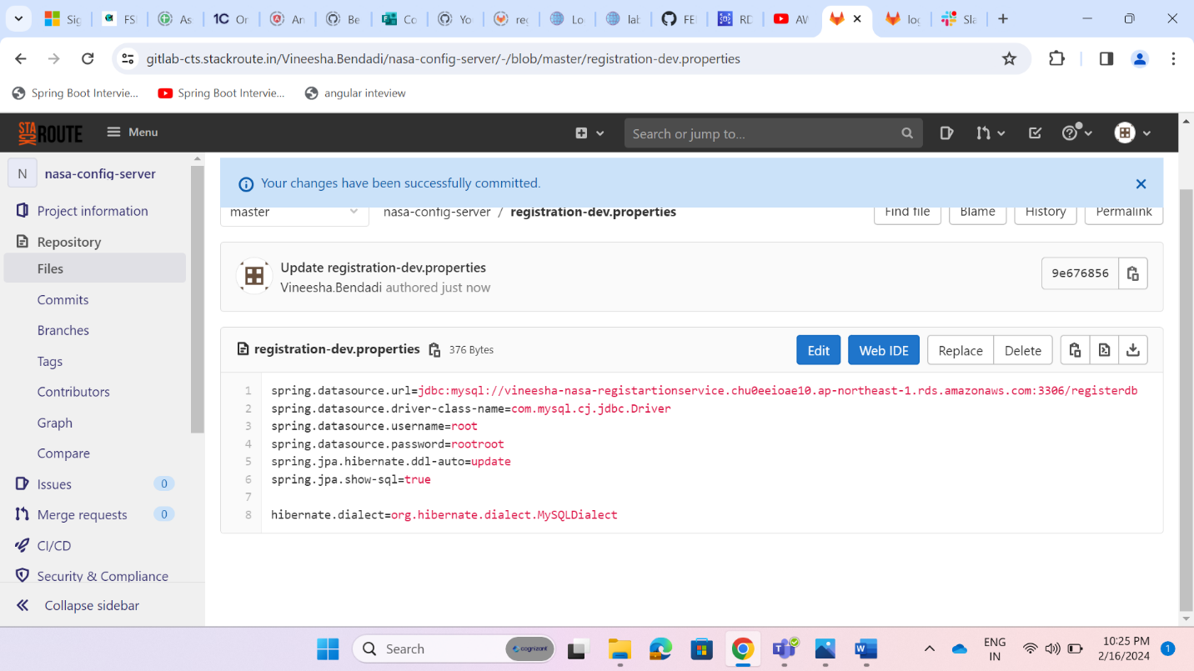

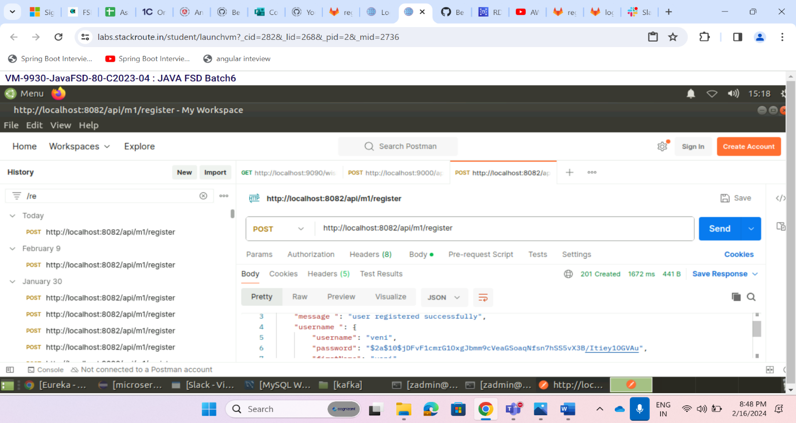

Rds mysql db:

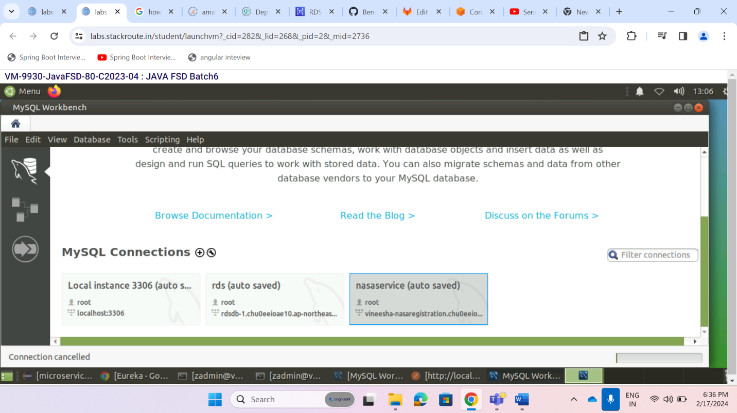

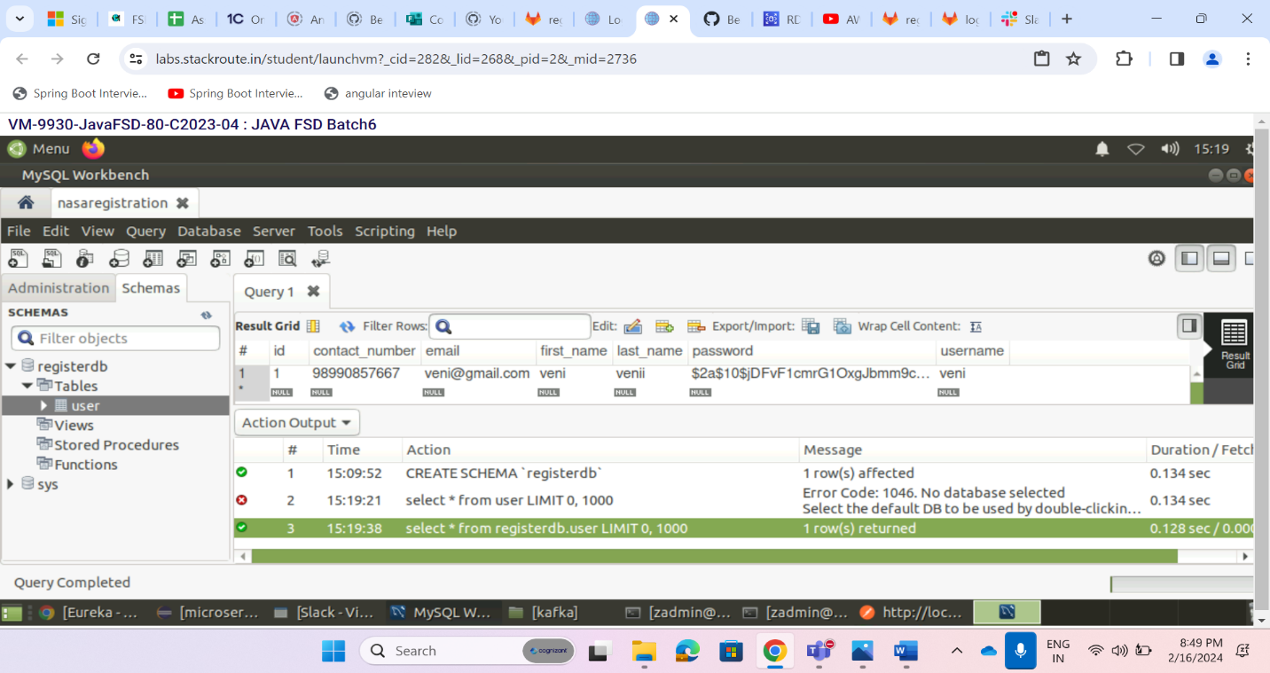

For Login:used same rds created database logindb



**Added securitygroup :edit inbound rules**

**CustomTcp 3306 anywhere**

local

#port number

server.port=8083

#application name

spring.application.name=login

#profiles

spring.profiles.active=dev

jwt.secret=some@secret#keys

#Kafka-topic

topic.name=t.user.details

spring.kafka.consumer.group-id=default

#eureka

eureka.client.serviceUrl.defaultZone=http://localhost:8762/eureka/

spring.datasource.url=jdbc:mysql://localhost:3306/logindb

spring.datasource.driver-class-name=com.mysql.cj.jdbc.Driver

spring.datasource.username=root

spring.datasource.password=Root@123

spring.jpa.hibernate.ddl-auto=update

spring.jpa.show-sql=true

#swagger

springdoc.swagger-ui.path=/swagger-ui.html

cloud

#port number

server.port=8083

#application name

spring.application.name=login

#profiles

spring.profiles.active=dev

jwt.secret=some@secret#keys

#Kafka-topic

topic.name=t.user.details

spring.kafka.consumer.group-id=default

#eureka

eureka.client.serviceUrl.defaultZone=http://localhost:8762/eureka/

spring.datasource.url=jdbc:mysql://vineesha-nasalogin.chu0eeioae10.ap-northeast-1.rds.amazonaws.com:3306/logindb

spring.datasource.driver-class-name=com.mysql.cj.jdbc.Driver

spring.datasource.username=root

spring.datasource.password=rootroot

spring.jpa.hibernate.ddl-auto=update

spring.jpa.show-sql=true

#swagger

springdoc.swagger-ui.path=/swagger-ui.html

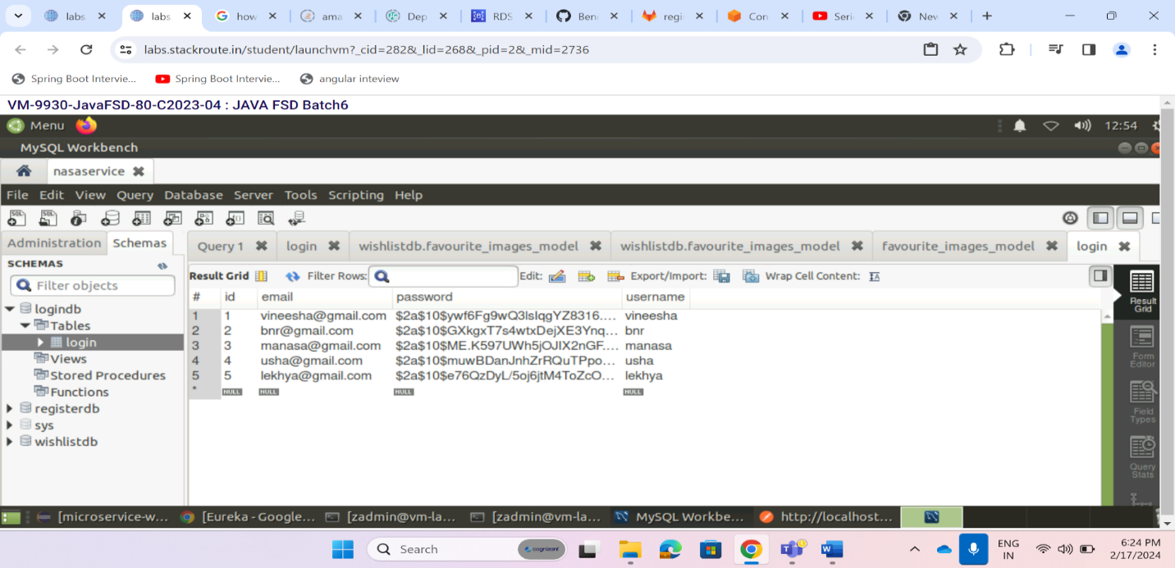

Ec2 Instances:

Eureka:

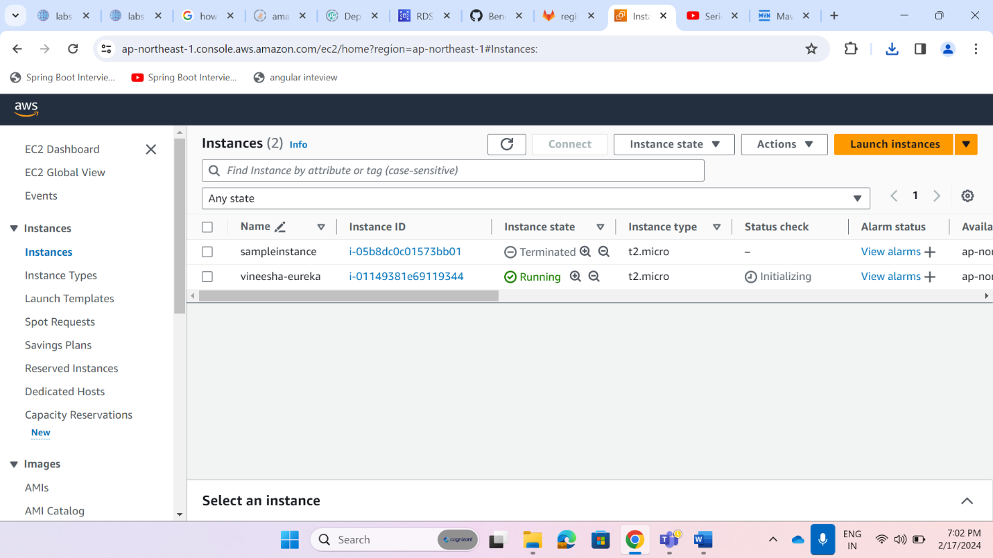

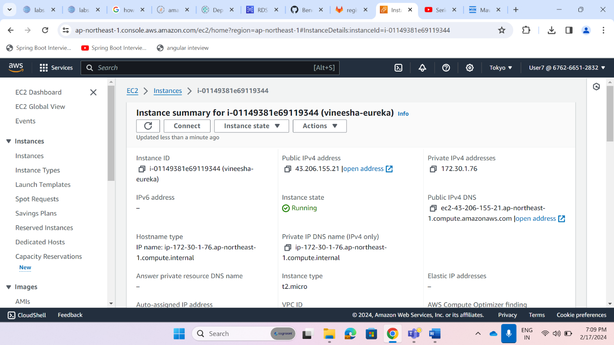

S3 bucket for eureka jar

[vineesha-nasa-eureka](https://s3.console.aws.amazon.com/s3/buckets/vineesha-nasa-eureka?region=ap-northeast-1)

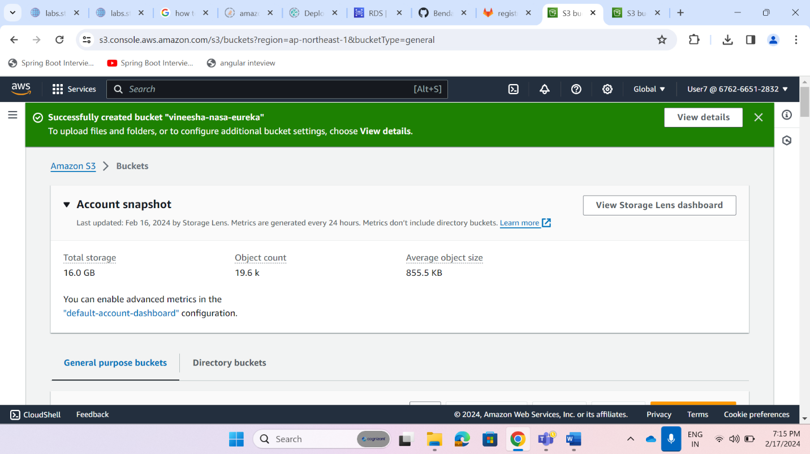

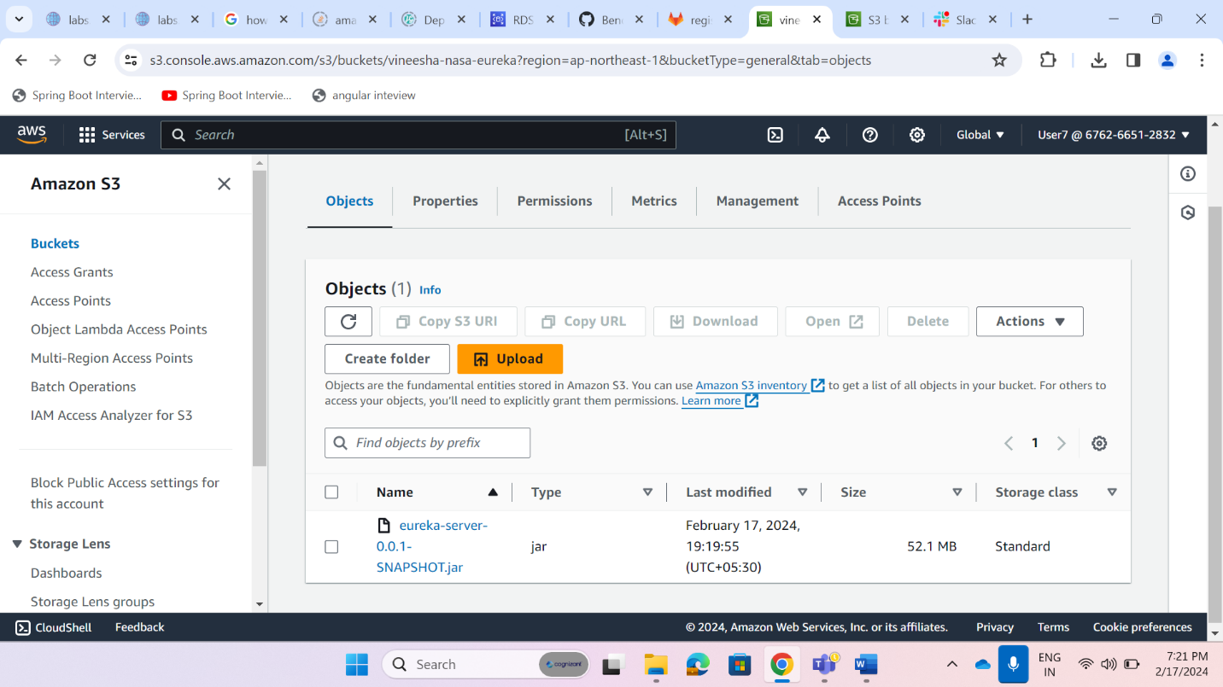

Added s3 bucket policy

Connect to Ec2 instance by using ssh

Steps:

sudo apt-get update

sudo apt install openjdk-17-jre-headless

java -version

wget <https://vineesha-nasa-eureka.s3.ap-northeast-1.amazonaws.com/eureka-server-0.0.1-SNAPSHOT.jar>

java -jar eureka-server-0.0.1-SNAPSHOT.jar

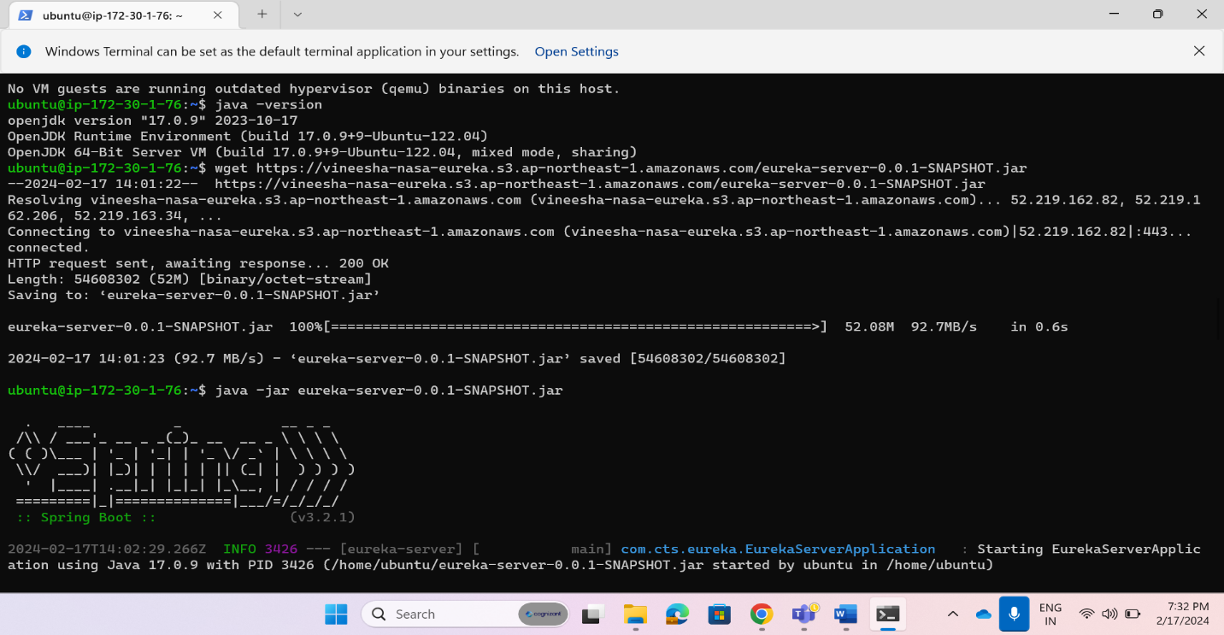

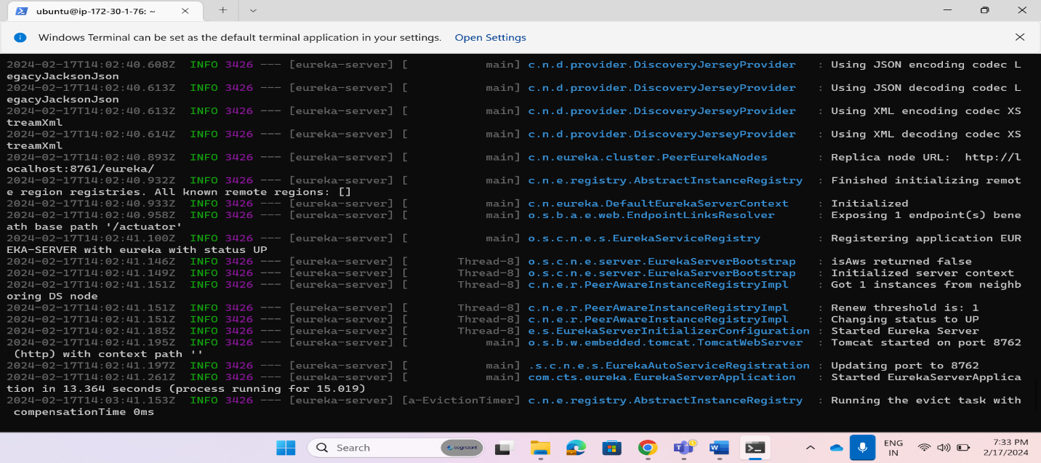

Open Public IPv4 address in Ec2 Instance (http://43.206.155.21:8762)

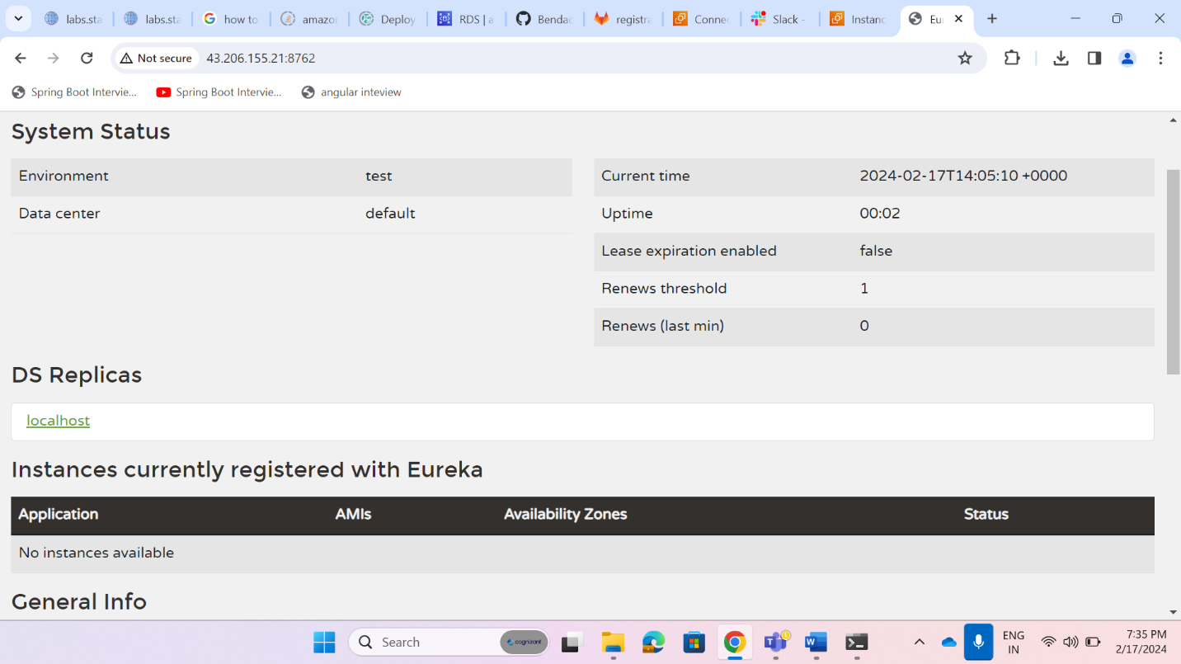

Ec2:api-gateway

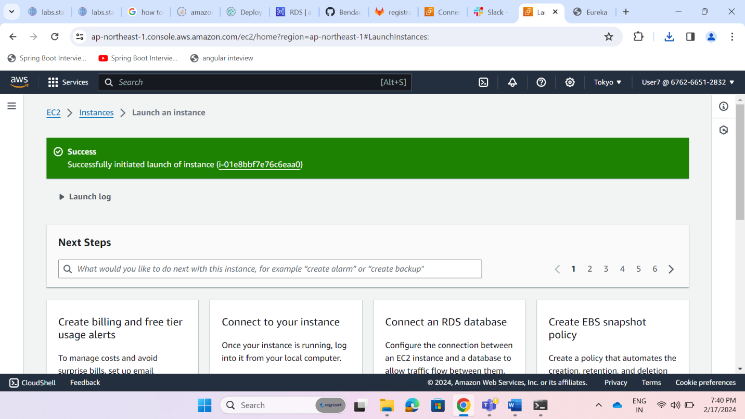

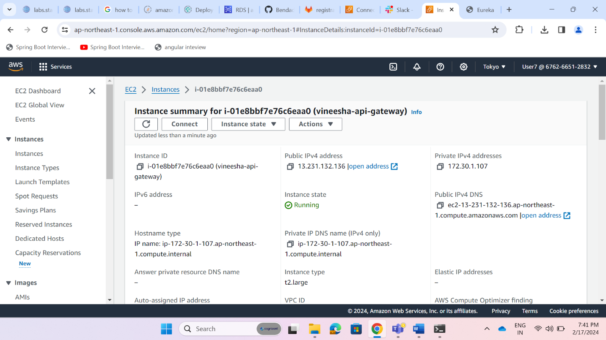

Add inbound properties for api-gateway ec2 instance

S3 bucket :Vineesha-s3-apigateway

Upload jar of api-gateway(changed eureka url in app.prop from localhost to eureka ec2 public ip)

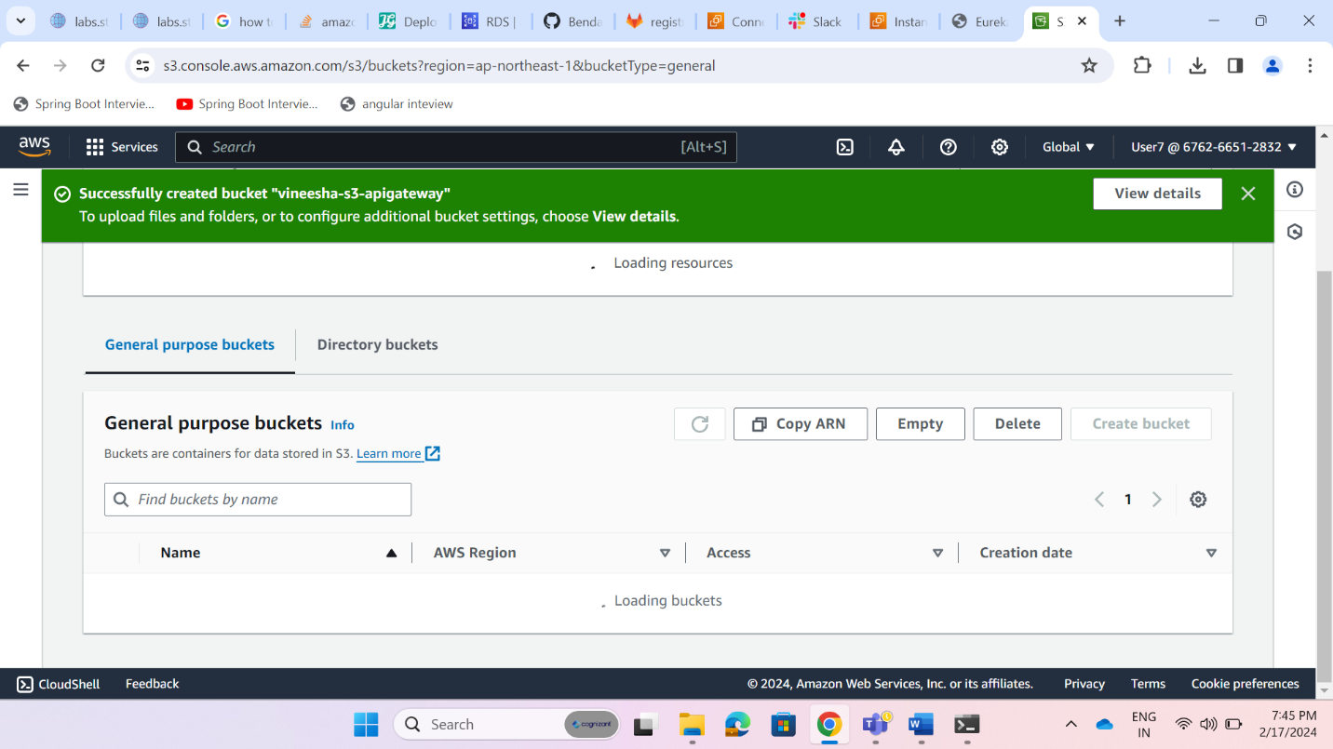

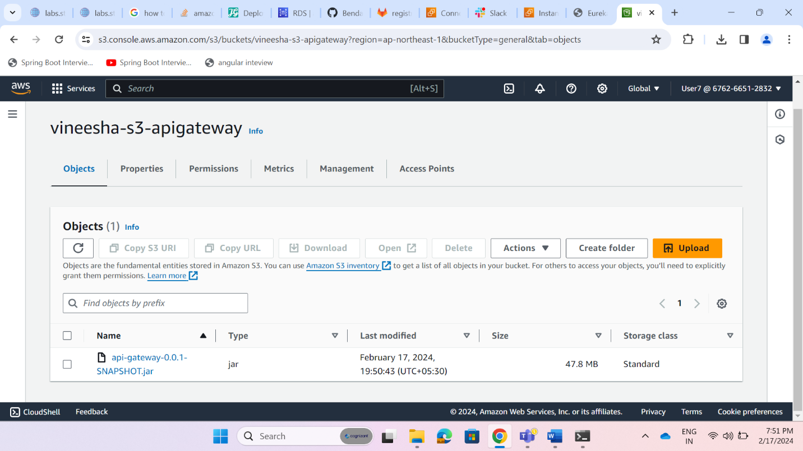

Create bucket policy

Connect to ec2 and do same command which done in eureka

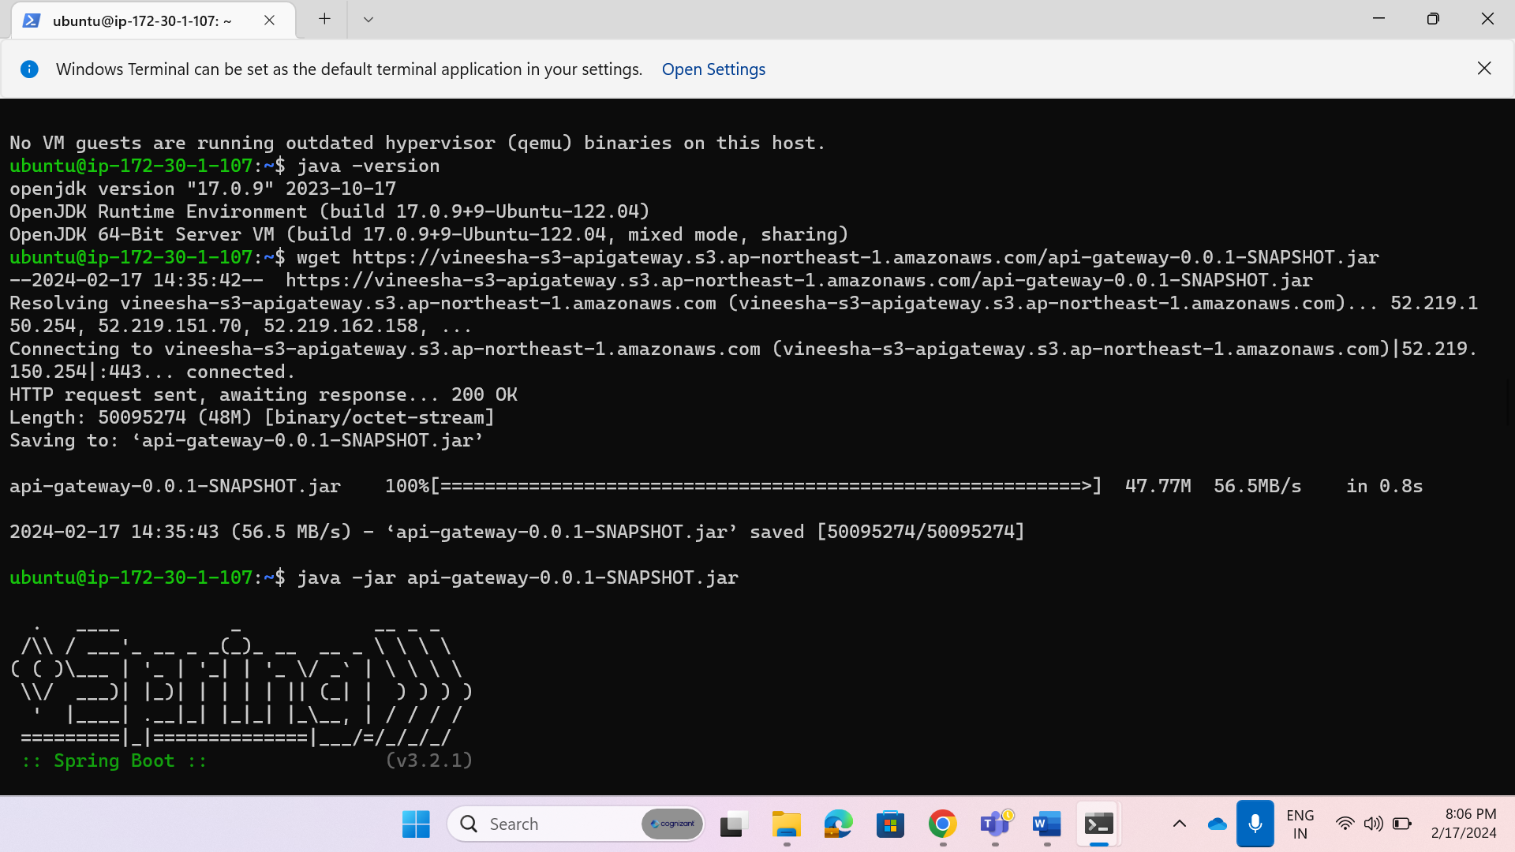

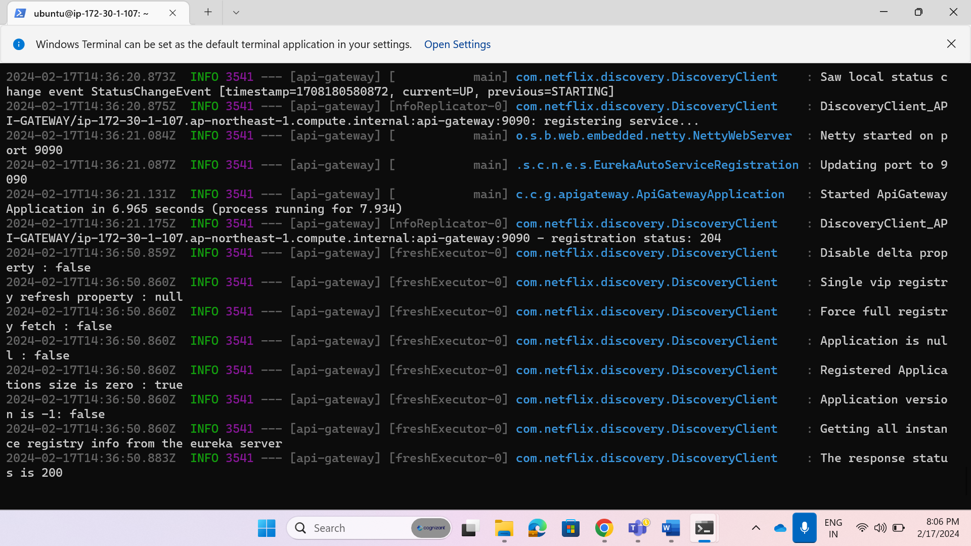

Check weather api-gateway registered with eureka or not

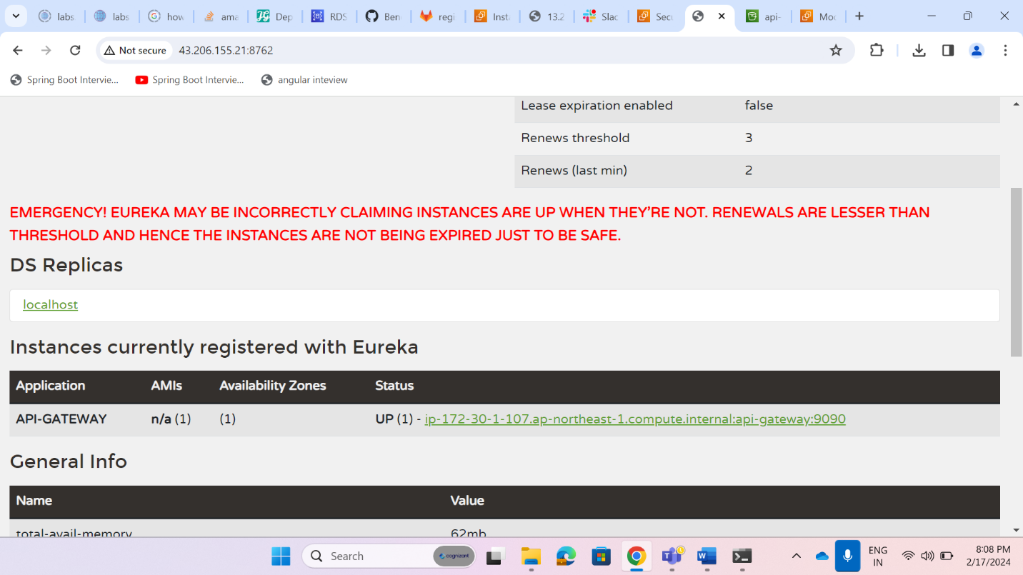

**Cloud deployment using Elastic bean stack**

**RDS**

**1)Created RDS for database**



**2)Testing the connection**

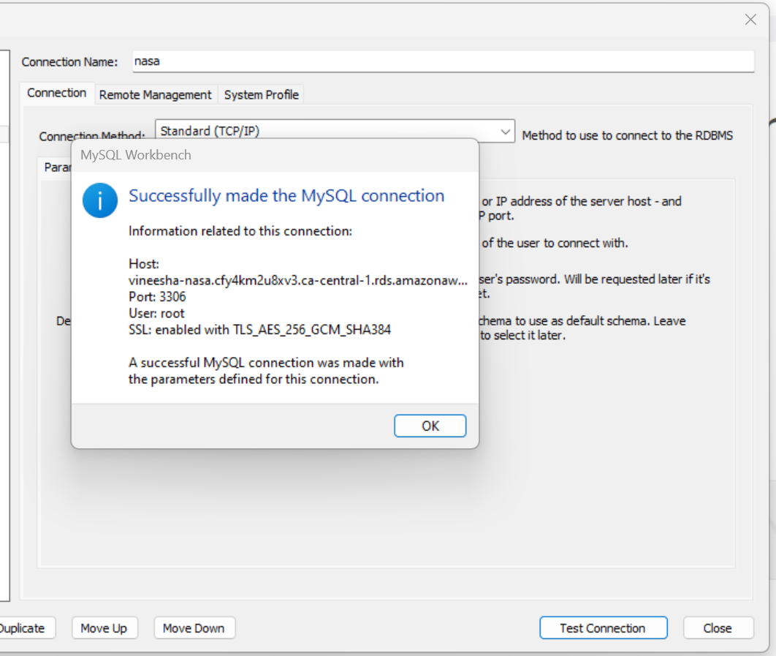

**3)Changed endpoints from localhost to Rds Endpoint in application.properties file**

For registration I used configserver to get database details,so after db creation in rds need to change endpoint,username and password username(root,pwd:rootroot) so change details in gitlab config server

local

spring.datasource.url=jdbc:mysql://localhost:3306/registerdb

spring.datasource.driver-class-name=com.mysql.cj.jdbc.Driver

spring.datasource.username=root

spring.datasource.password=Root@123

spring.jpa.hibernate.ddl-auto=update

spring.jpa.show-sql=true

after cloud

spring.datasource.url=jdbc:mysql://vineesha-nasaregistration.chu0eeioae10.ap-northeast-1.rds.amazonaws.com:3306/registerdb

spring.datasource.driver-class-name=com.mysql.cj.jdbc.Driver

spring.datasource.username=root

spring.datasource.password=rootroot

spring.jpa.hibernate.ddl-auto=update

spring.jpa.show-sql=true

tested with cloud



**4) Added securitygroup :edit inbound rules**

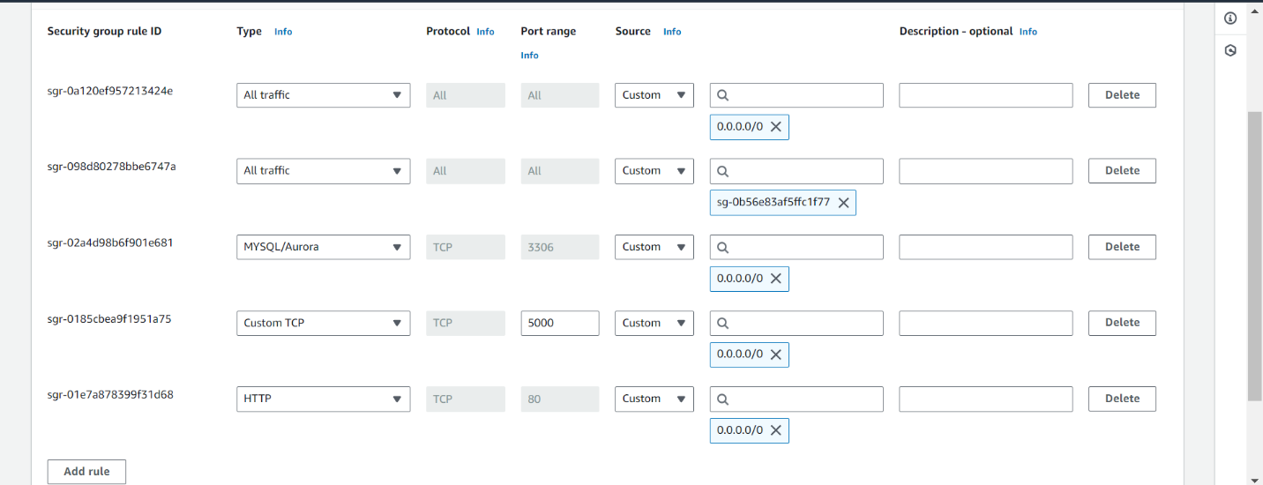

**5)Testing through postman**



**6)Rds mysql db:**



**7)created databases in RDS for services and tested**



**IAM**

1)Created IAM role1 **Role vineesha-ebs-role**

2)Create IAM role1 Role **vineesha-ec2-role**

**Elastic BeanStalk**

**1)Created Ebs Environment by using following steps here we will upload jar files of respective services**

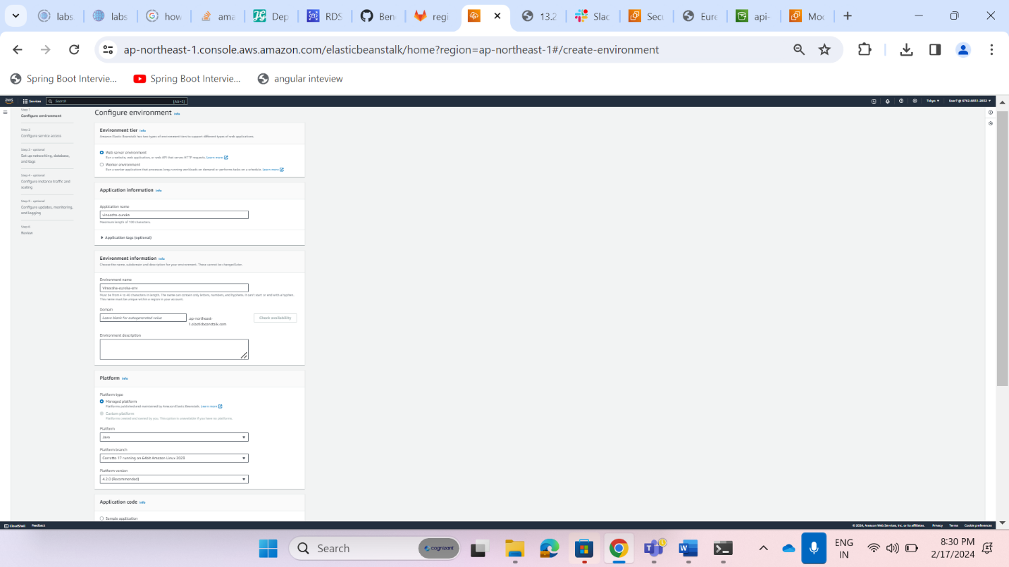

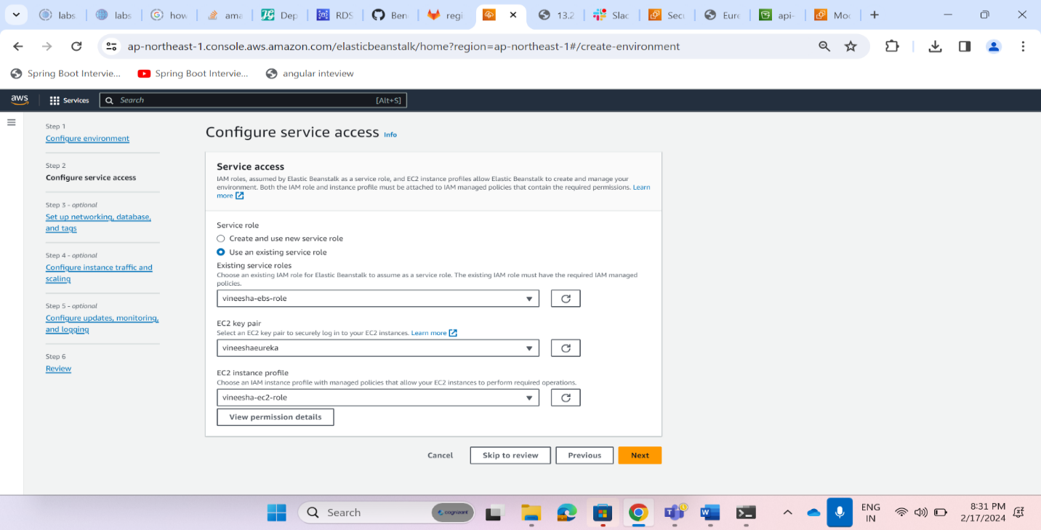

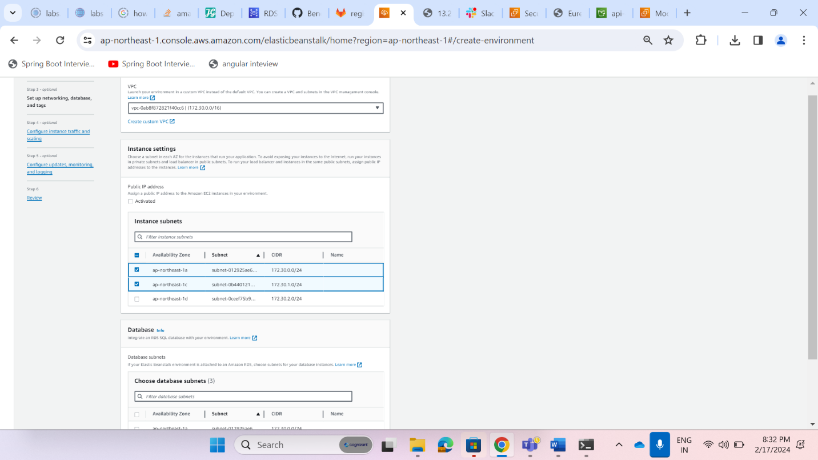

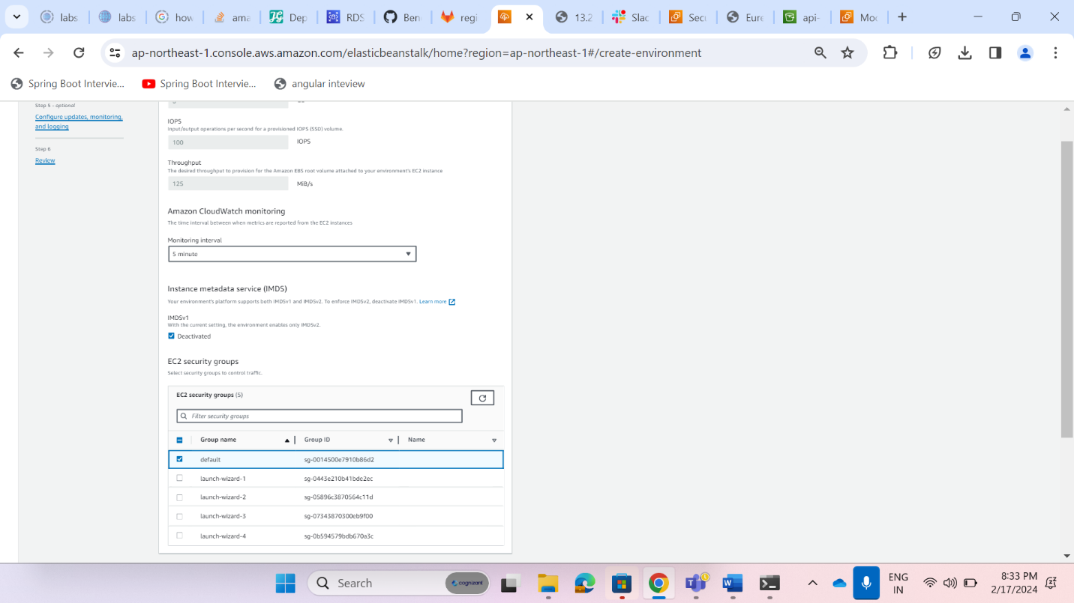

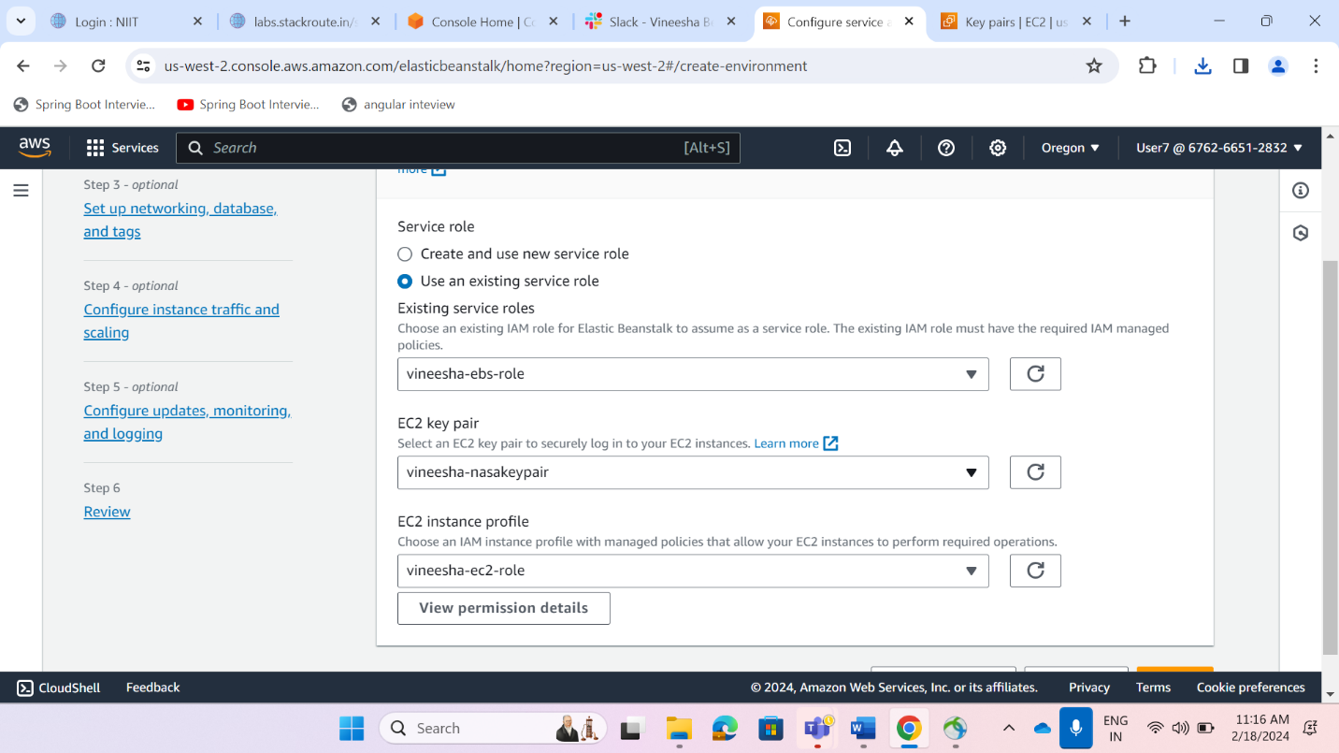

**Environment for services eureka,api-gateway,config,registration,login,nasa-service,wishlist**

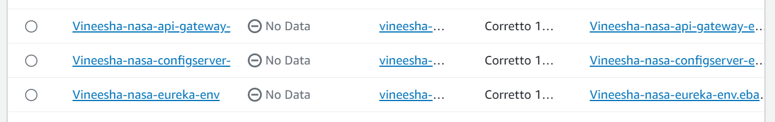

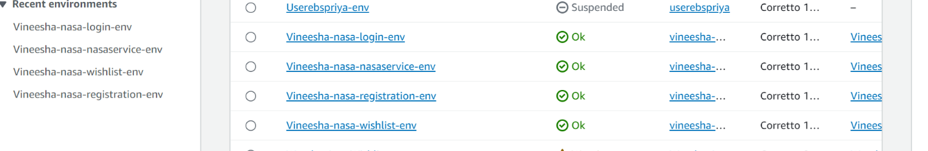

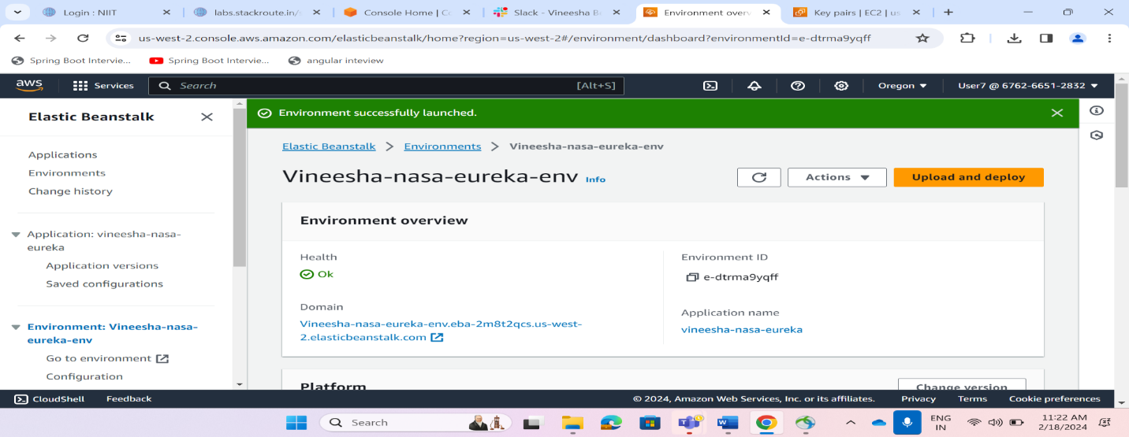

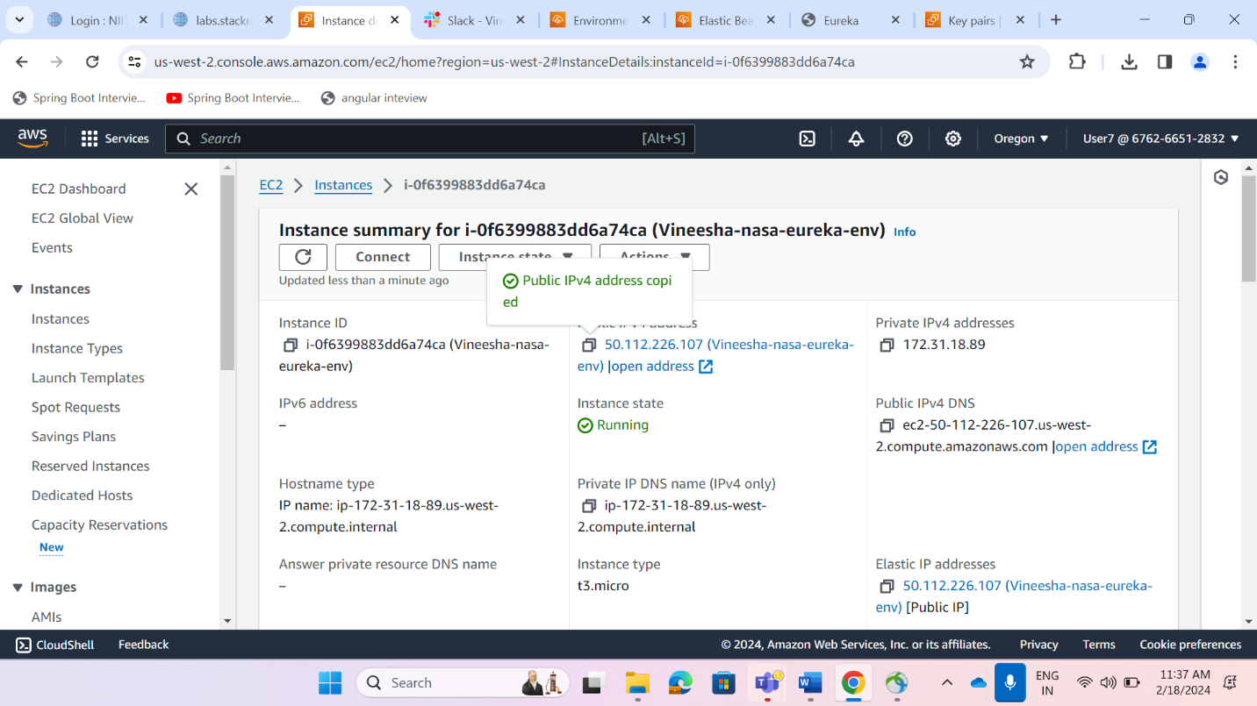

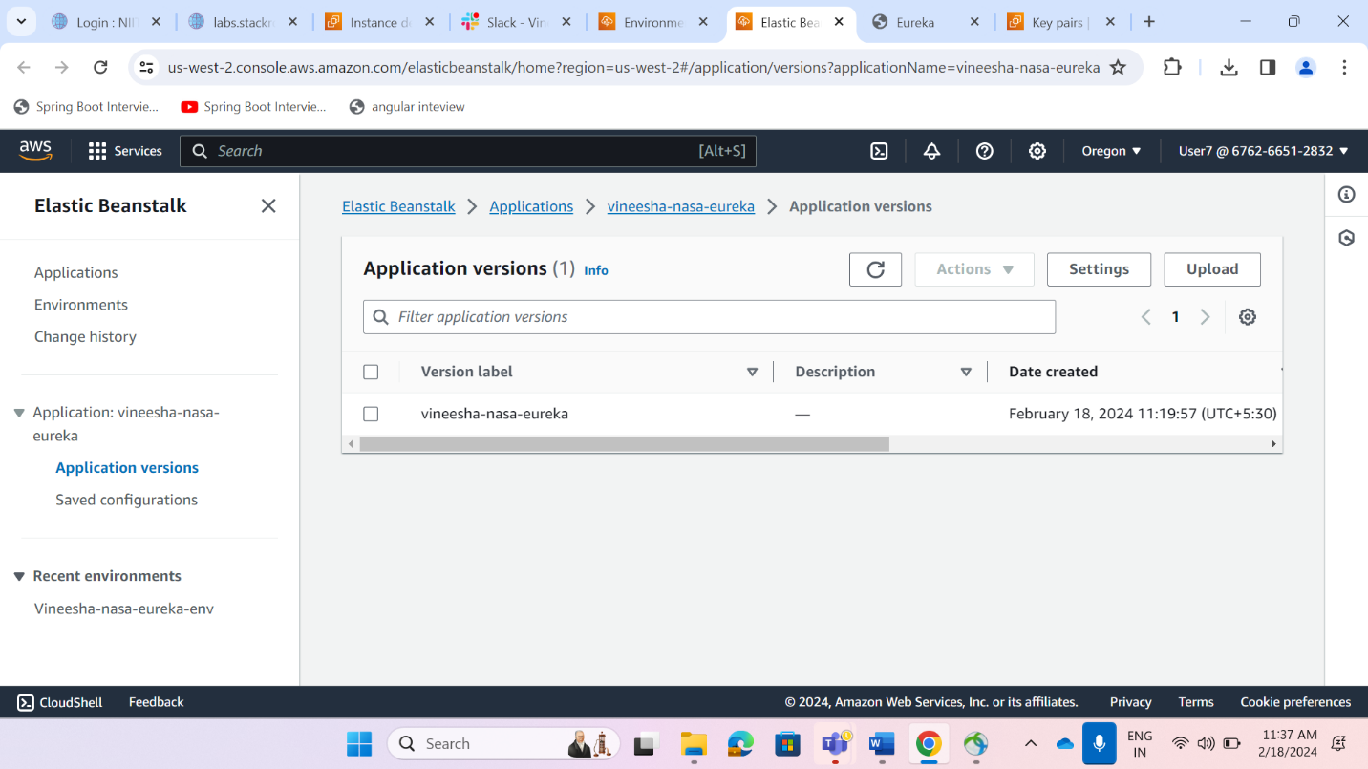

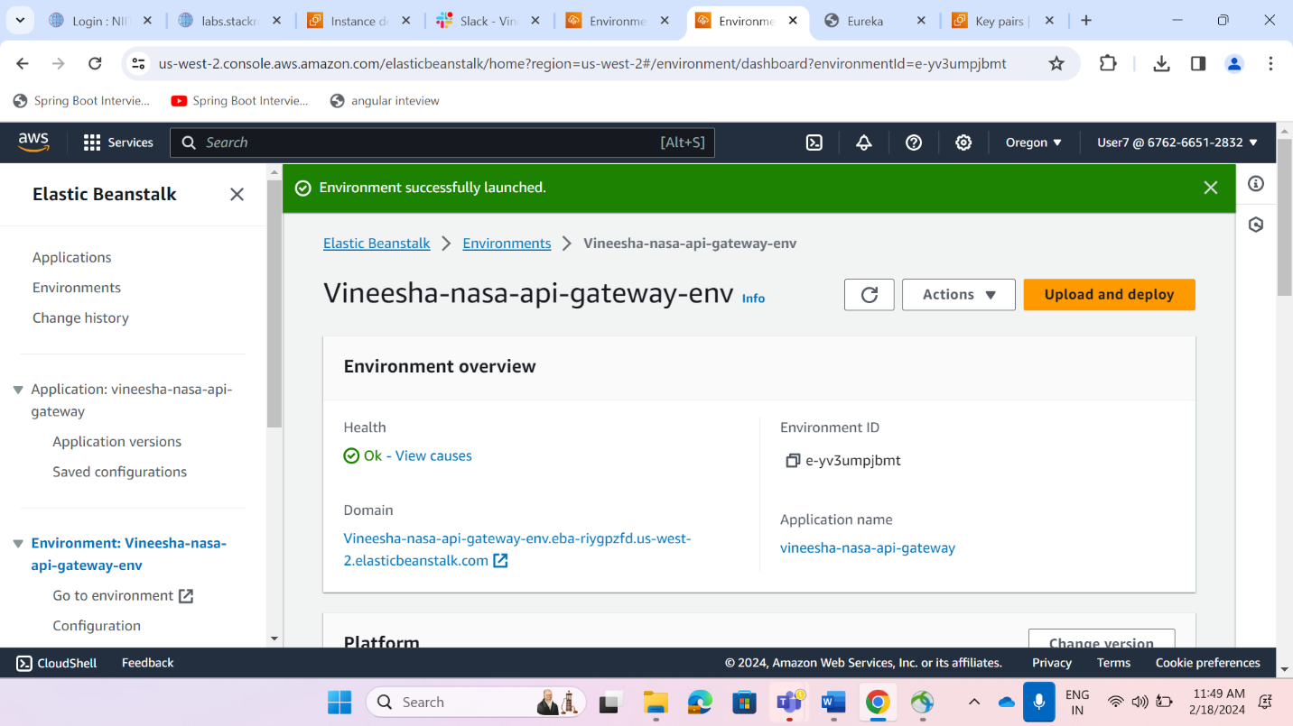

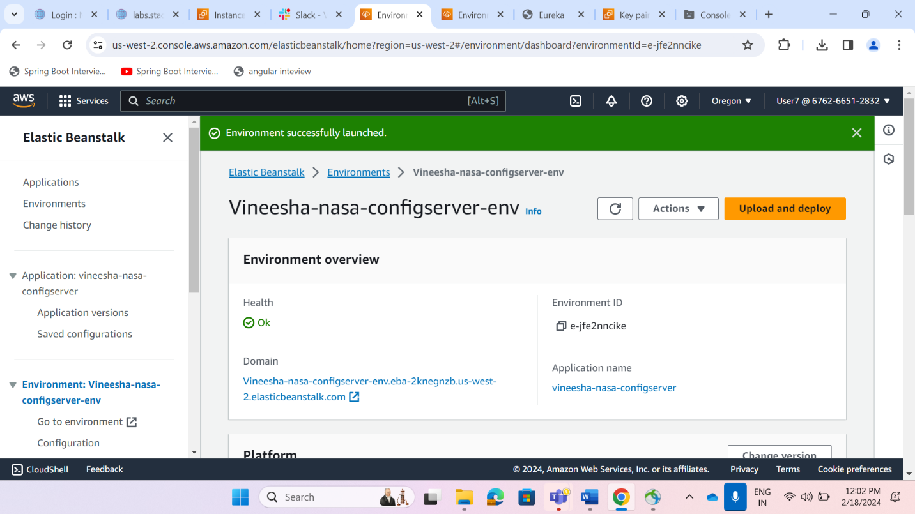

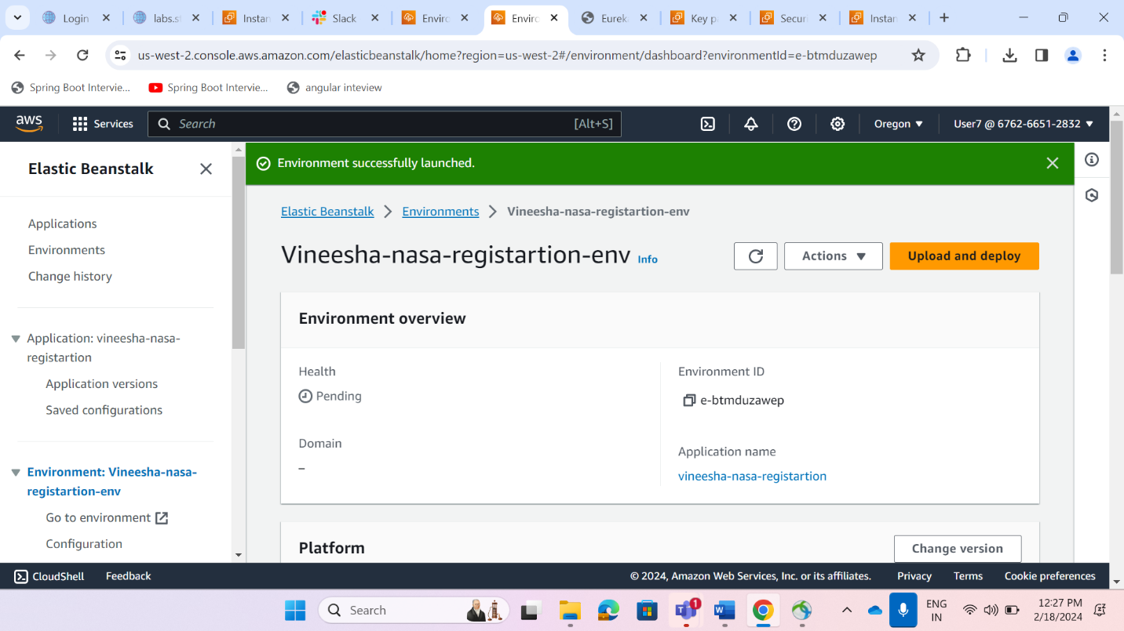

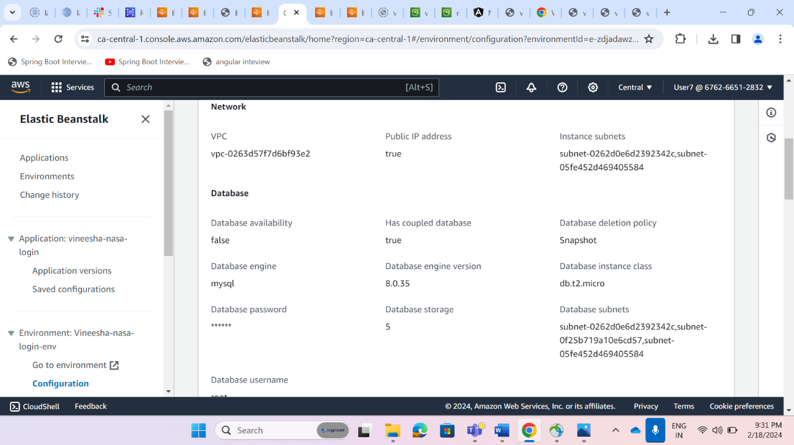

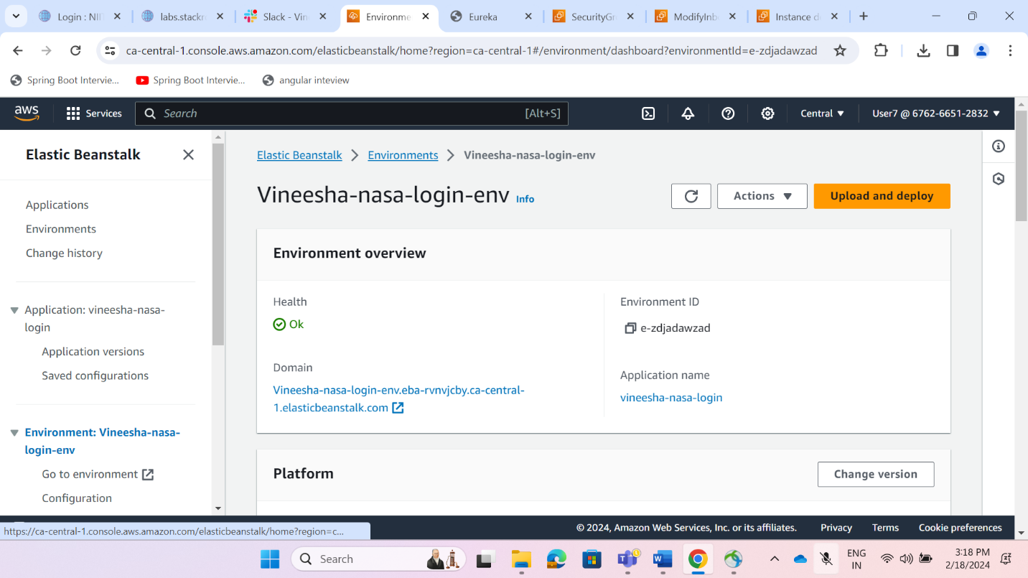

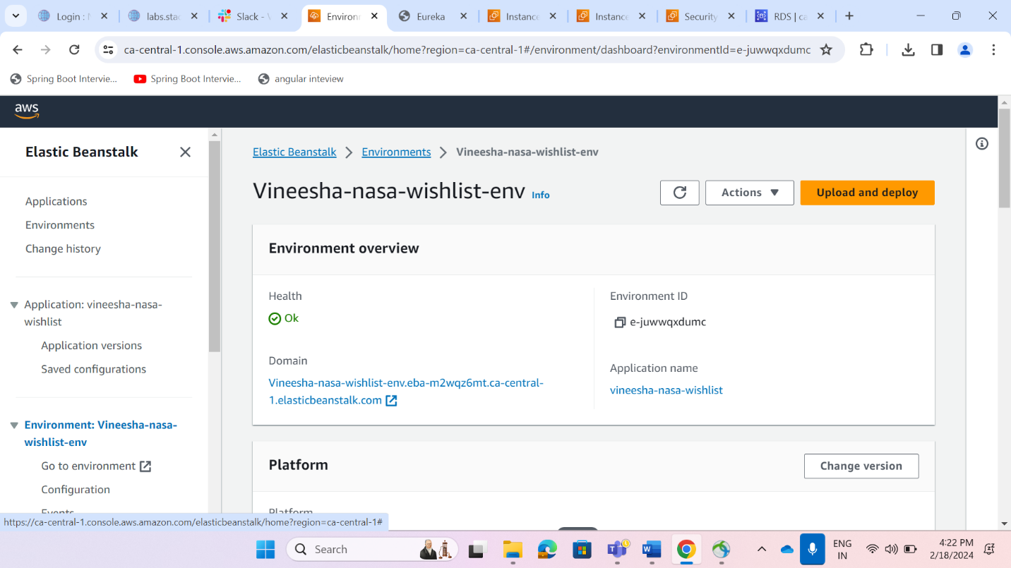

**Updated Ebs Domain in backend services**

**By creating ebs Ec2 instance will get created that Ec2 public IP address used in app.properties file**

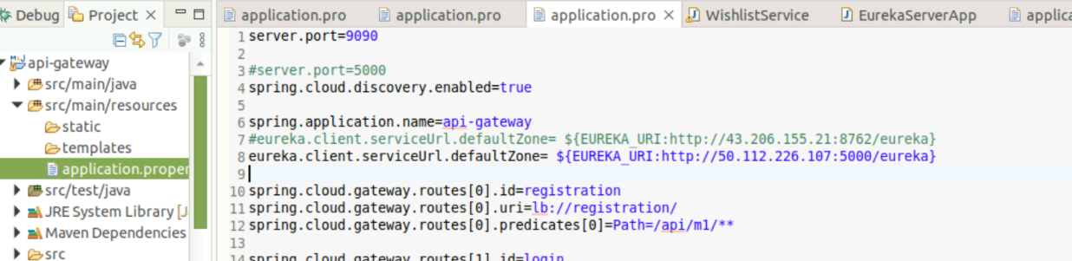

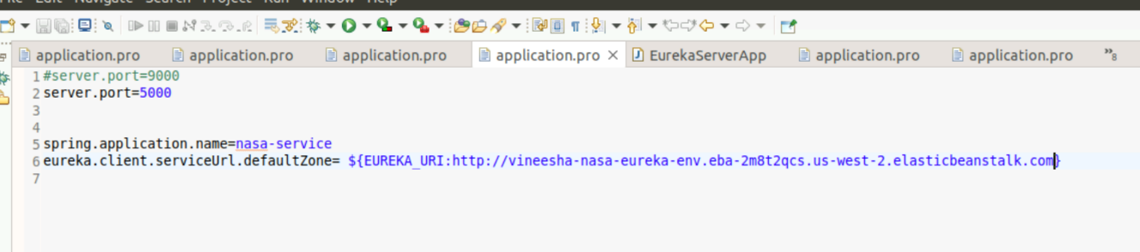

**Copy public ip address and changed app.prop of eureka url of ec2 or ebs and check Eureka launched successfully or not**

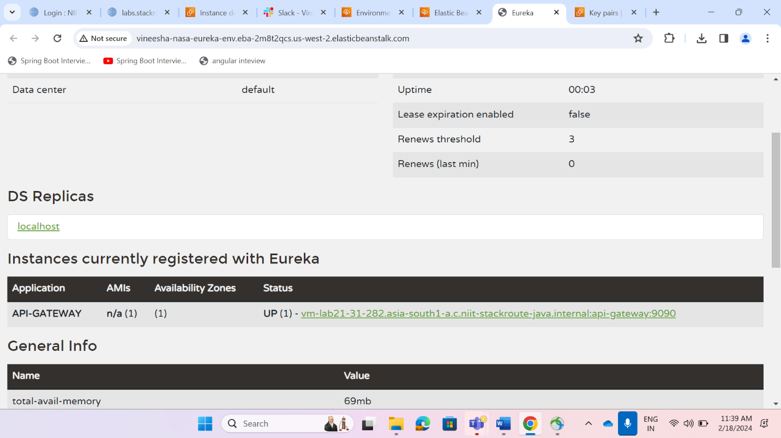

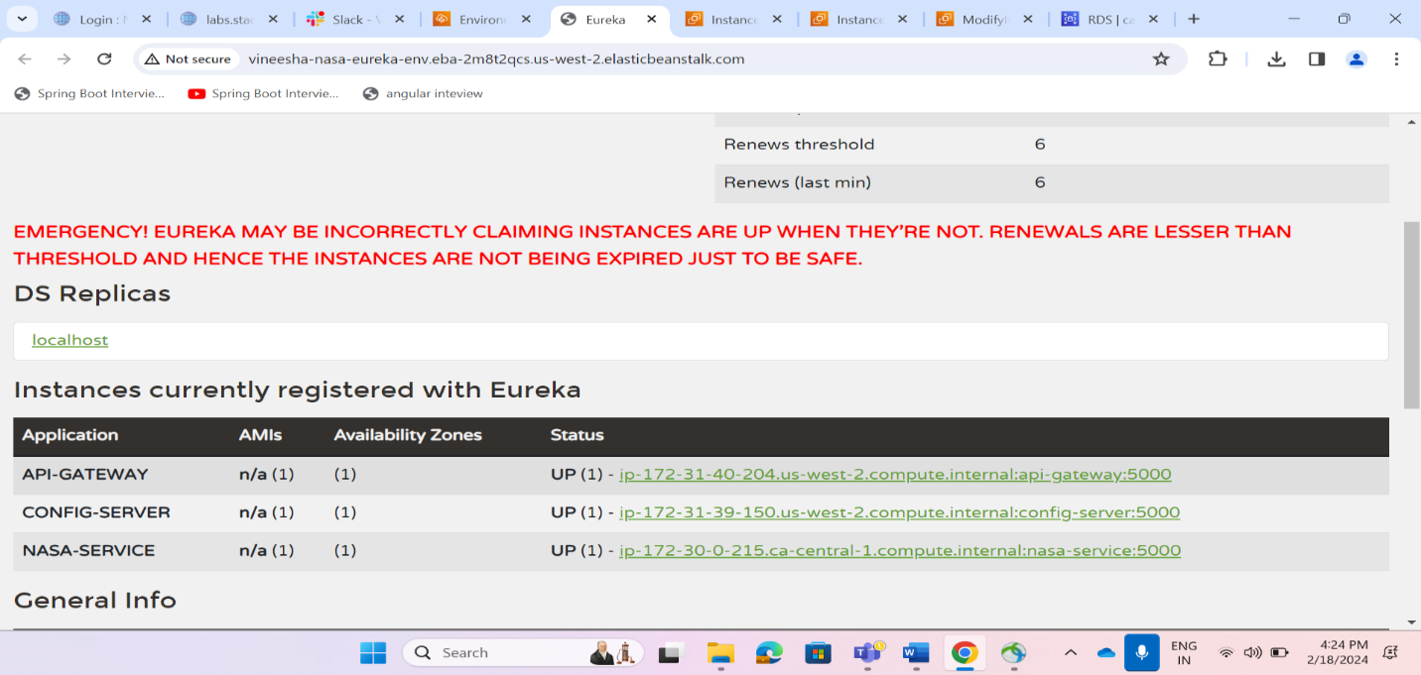

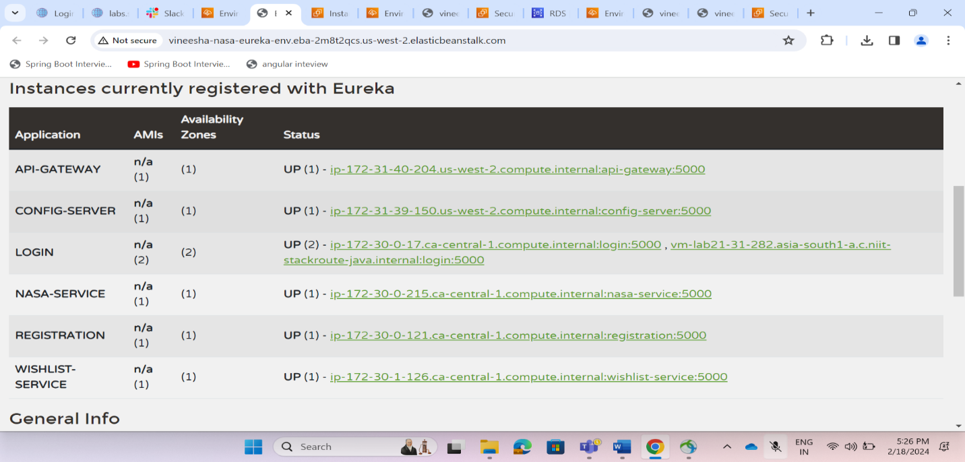

Tested services endpoints using elastic beanstalk urls

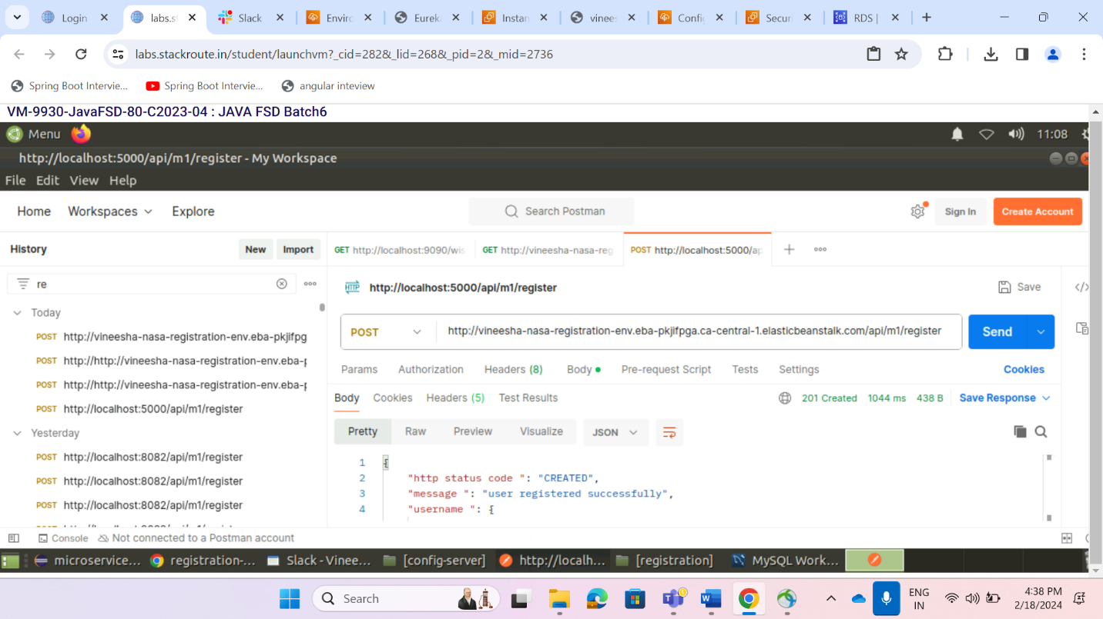

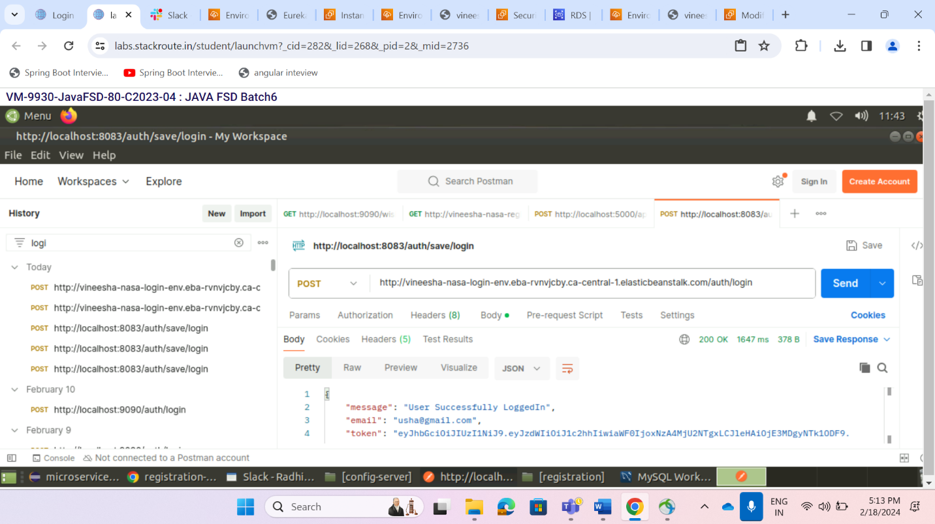

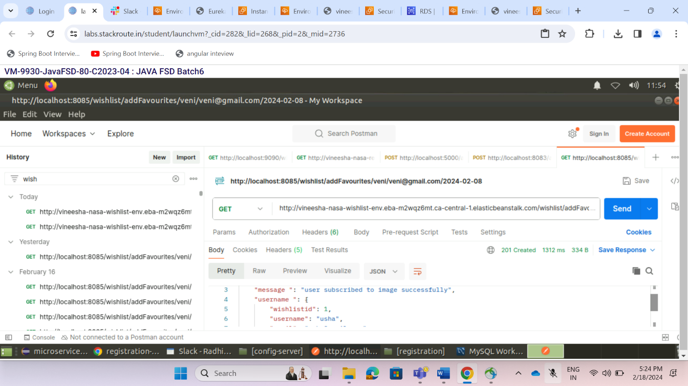

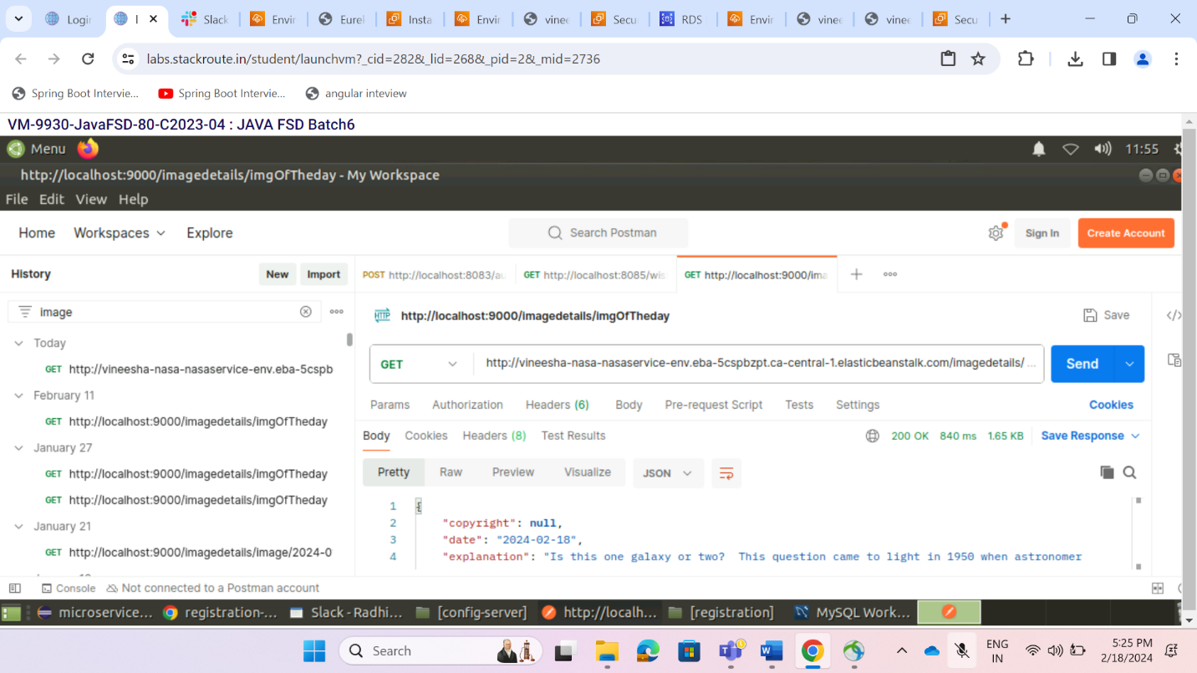

**Environment Domain of ebs:**

<http://vineesha-nasa-eureka-env.eba-2m8t2qcs.us-west-2.elasticbeanstalk.com/---eureka>

<http://vineesha-nasa-api-gateway-env.eba-riygpzfd.us-west-2.elasticbeanstalk.com/--api-gateway>

<http://vineesha-nasa-registration-env.eba-pkjifpga.ca-central-1.elasticbeanstalk.com/--registratio>n

<http://vineesha-nasa-login-env.eba-rvnvjcby.ca-central-1.elasticbeanstalk.com/---login>

<http://vineesha-nasa-nasaservice-env.eba-5cspbzpt.ca-central-1.elasticbeanstalk.com/---nasaservice>

<http://vineesha-nasa-wishlist-env.eba-m2wqz6mt.ca-central-1.elasticbeanstalk.com/--wishlist>

**Created s3 bucket to deploy frontend(Vineesha-nasaapp-bucket)**

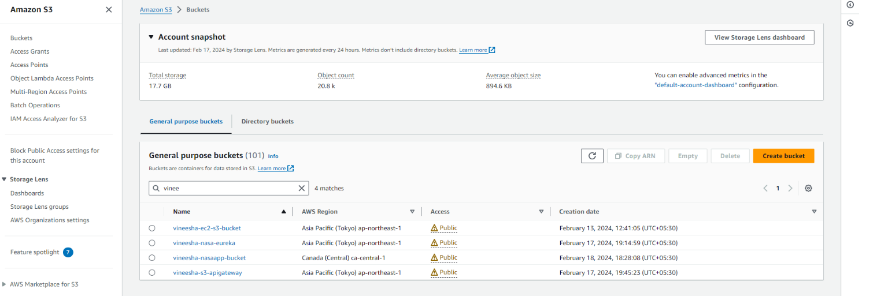

**Changed Service urls in front end**

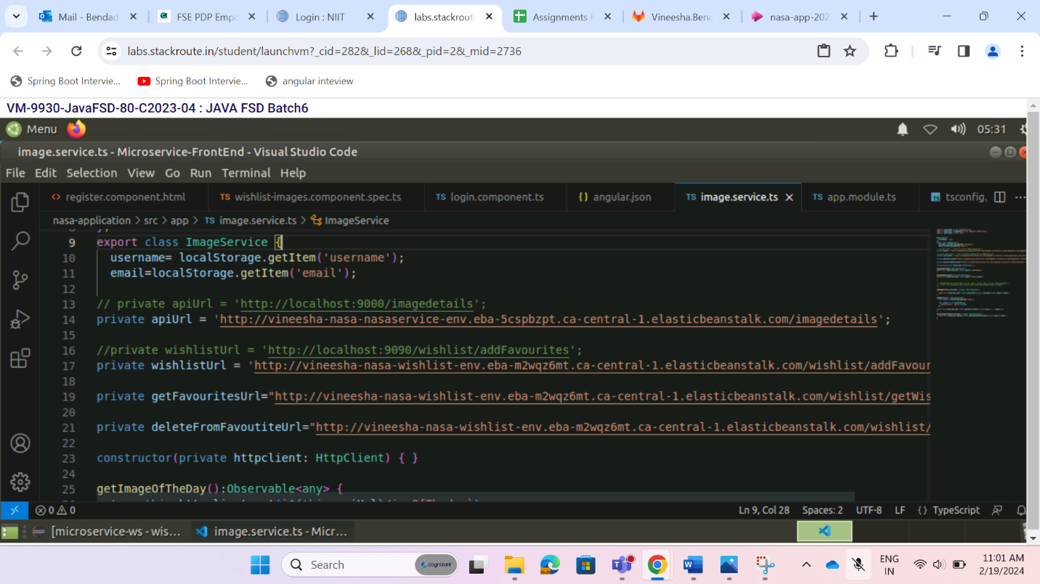

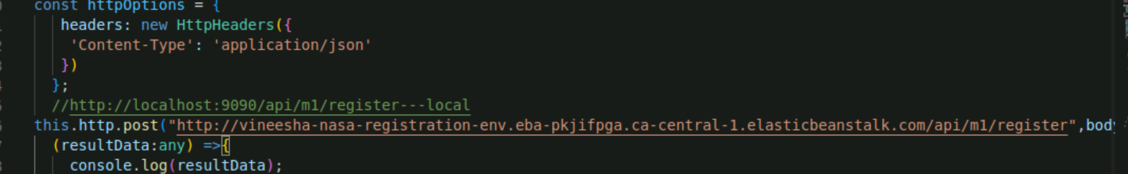

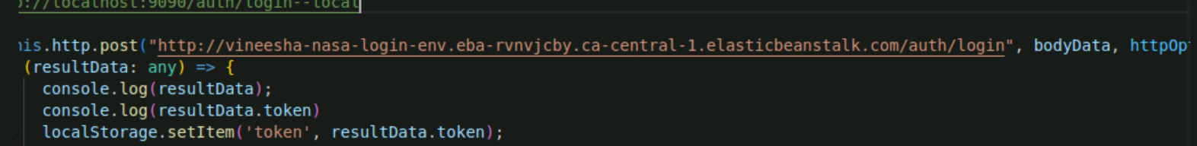

**Generated dist folder by using ng build command**

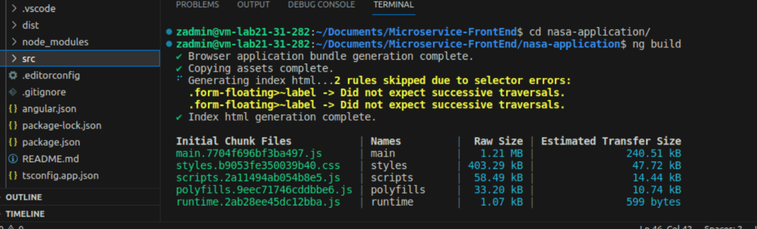

**Uploaded dist folder generated component folder in s3 bucket**

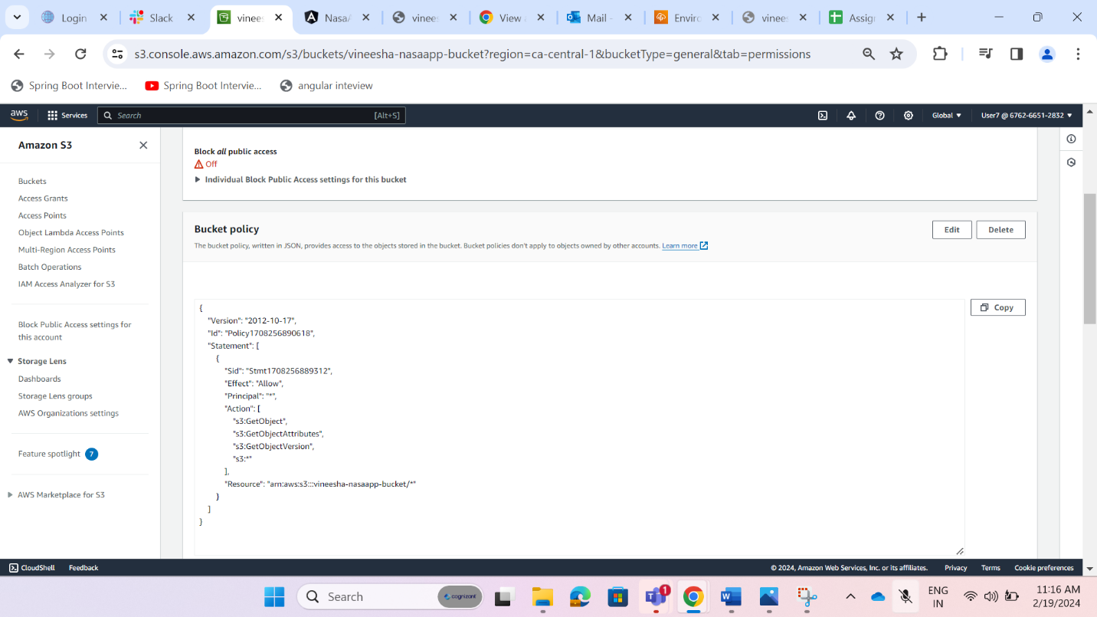

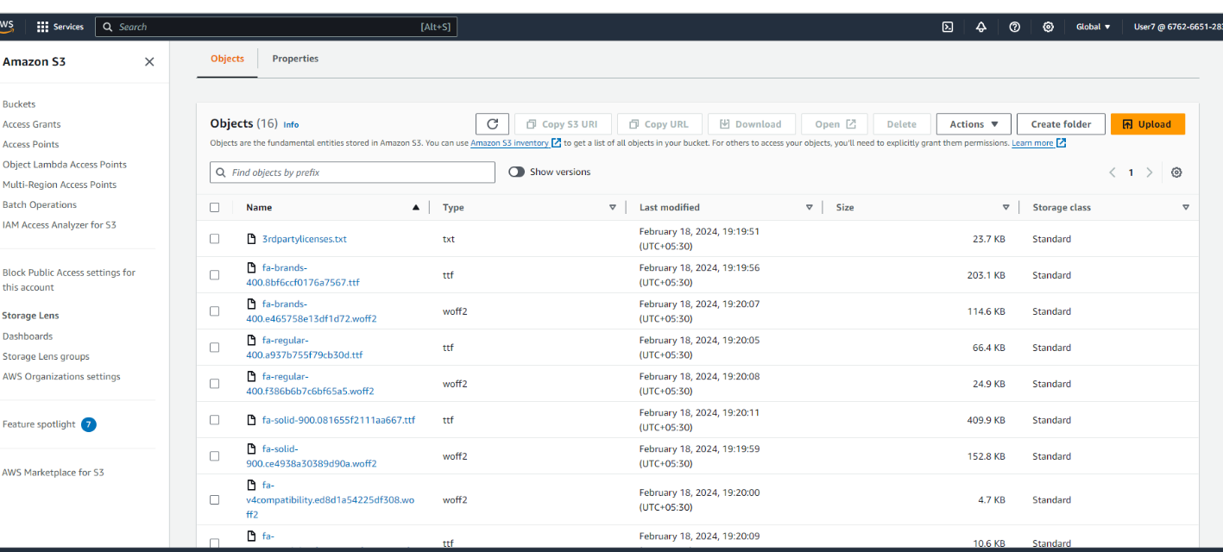

**Enable Static website hosting in s3 bucket**

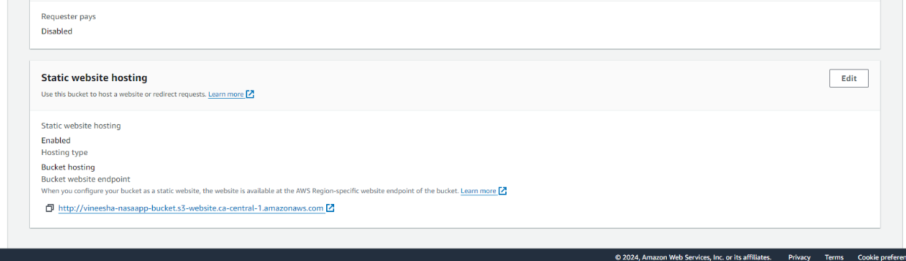

**Frontend with backend deployment successful in AWS**

